**AWS ASSIGNMENT**

1. **Create a virtual network with 2 subnets. Each subnet should have 16 Ips only.**

* **Creating a VPC**

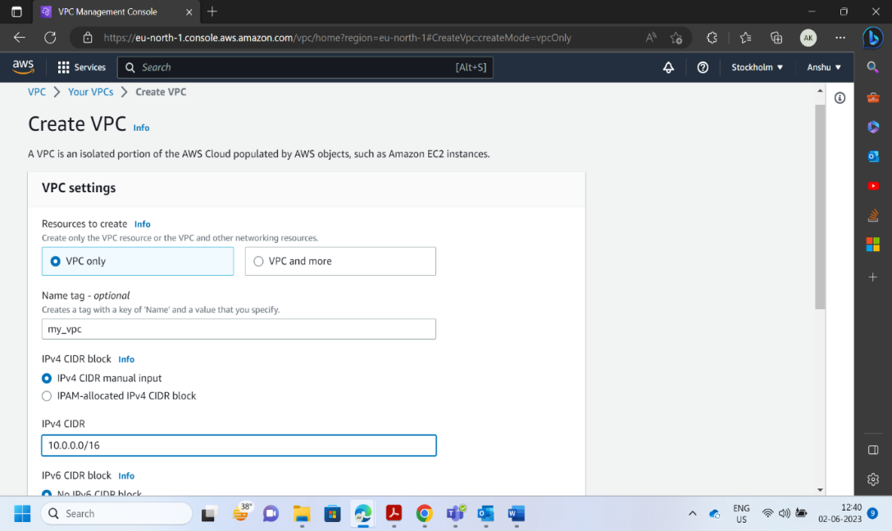

* **VPC is successfully Created.**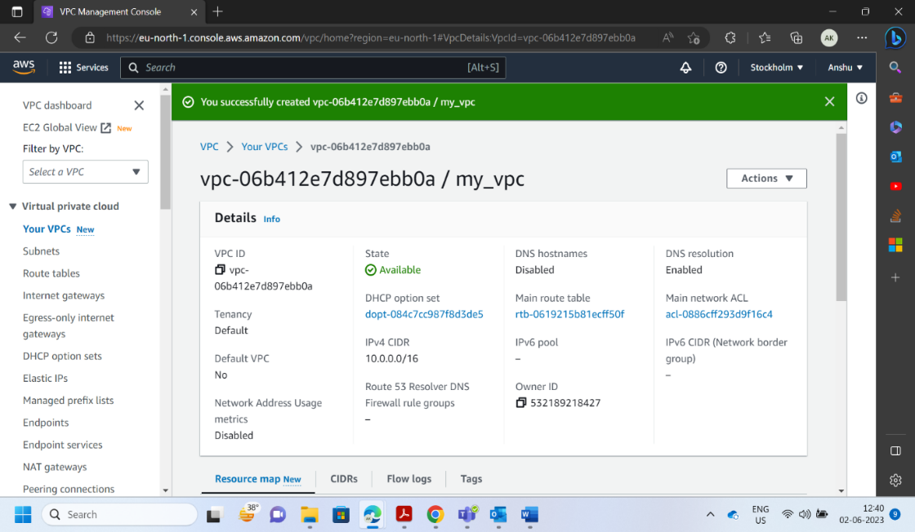
* **Creating Subnet 1 with 16 Ips.**

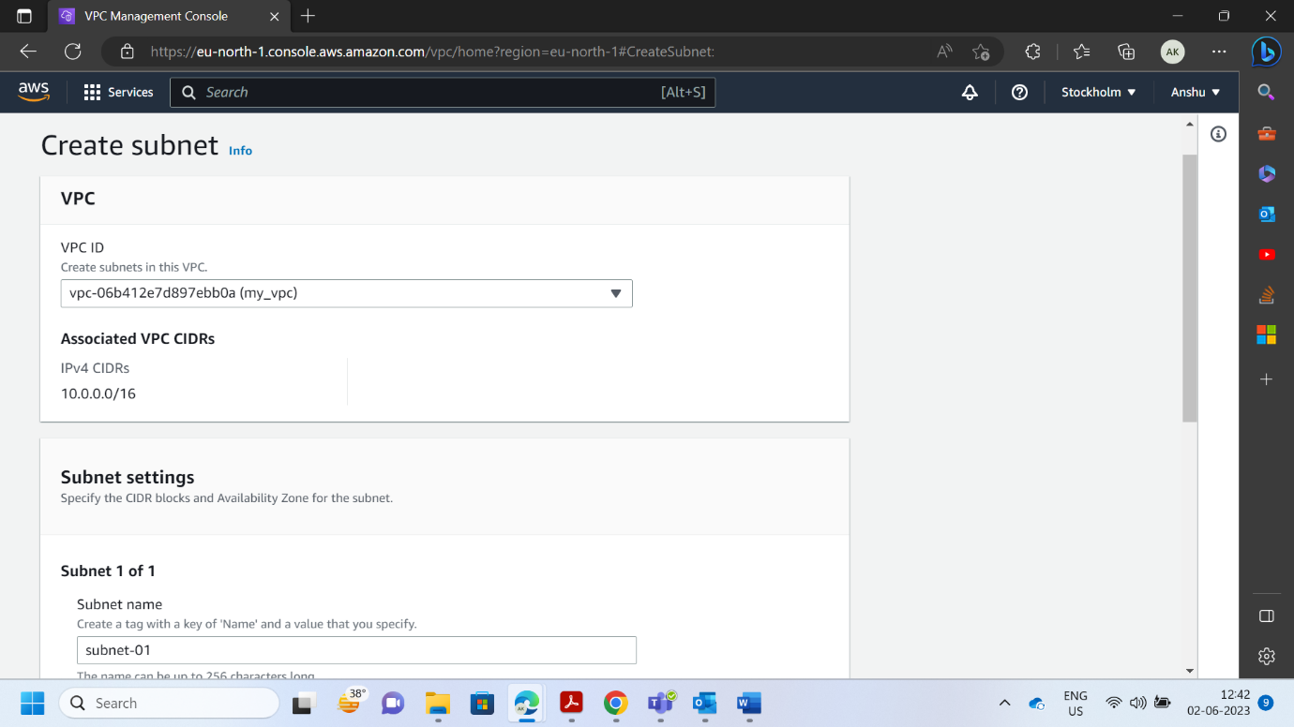

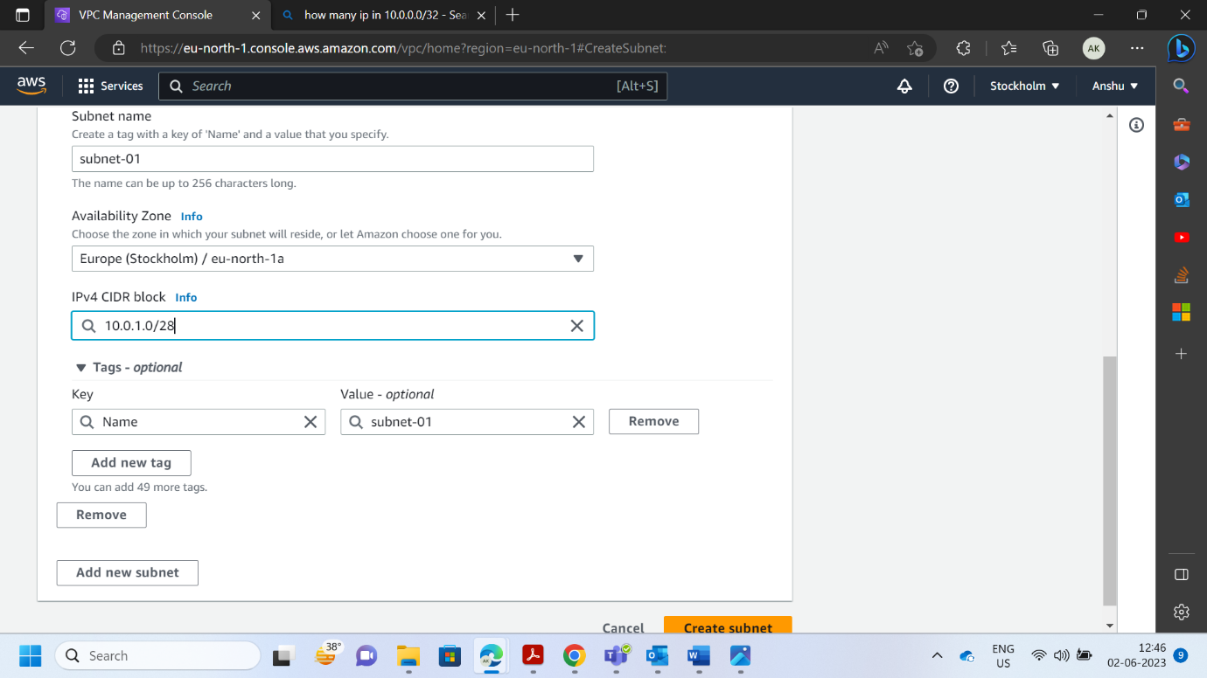

* **Creating Subnet 2 with 16 Ips.**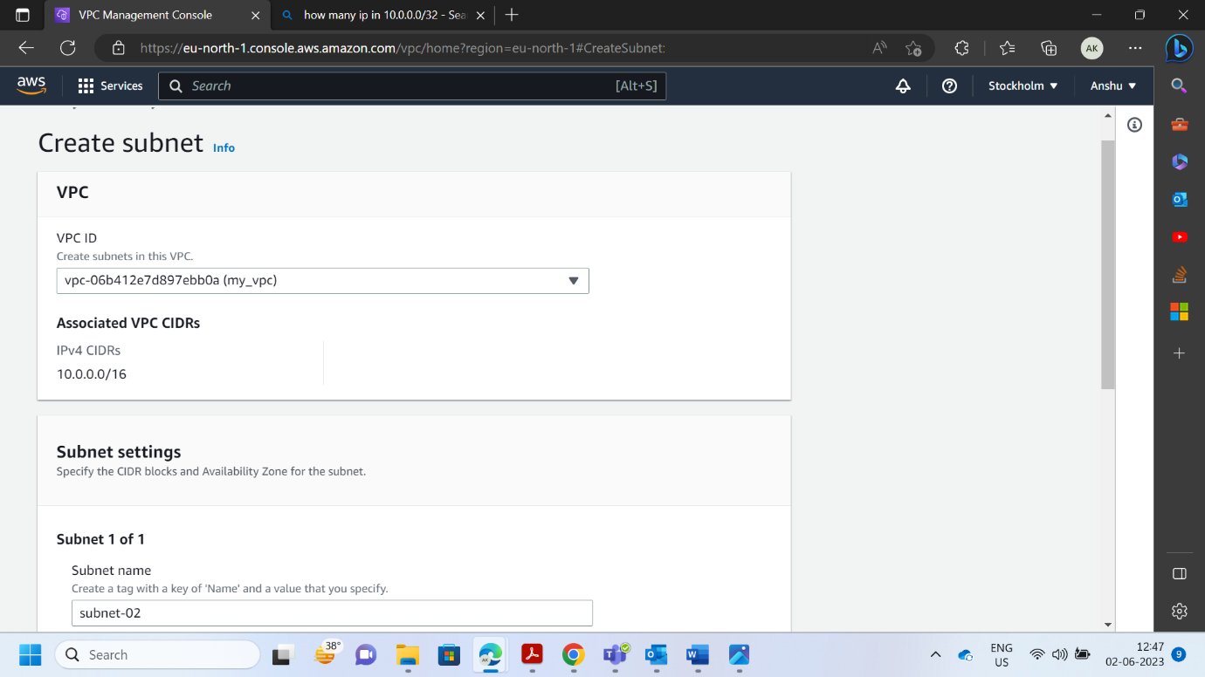

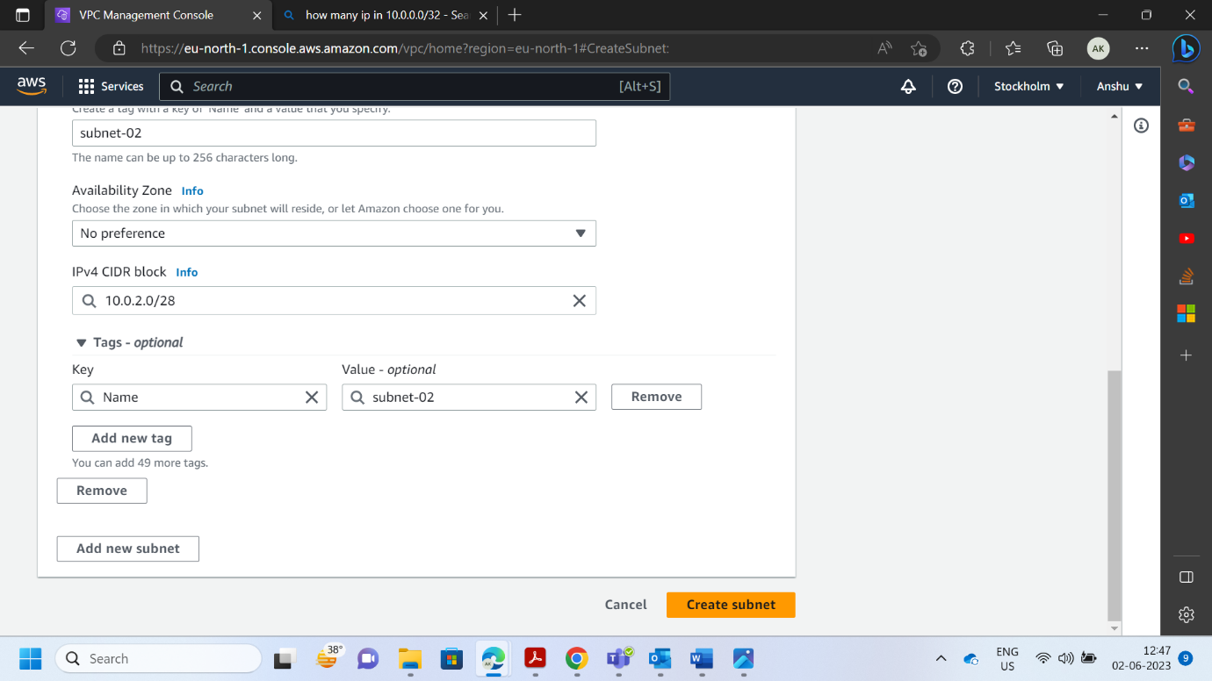

* **Both Subnets Created Successfully.**

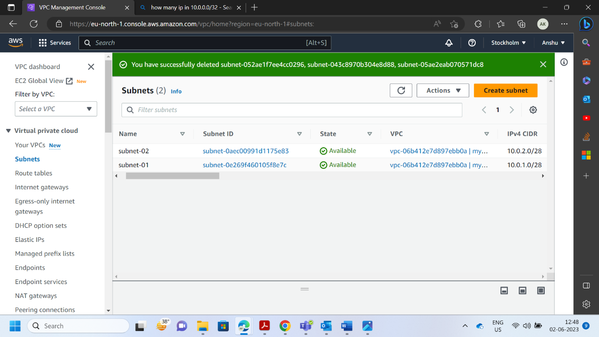

1. **Inside one of the subnets, create a VM and deploy an application code inside it (any existing application created by you before).**

* **Creating Internet Gateway**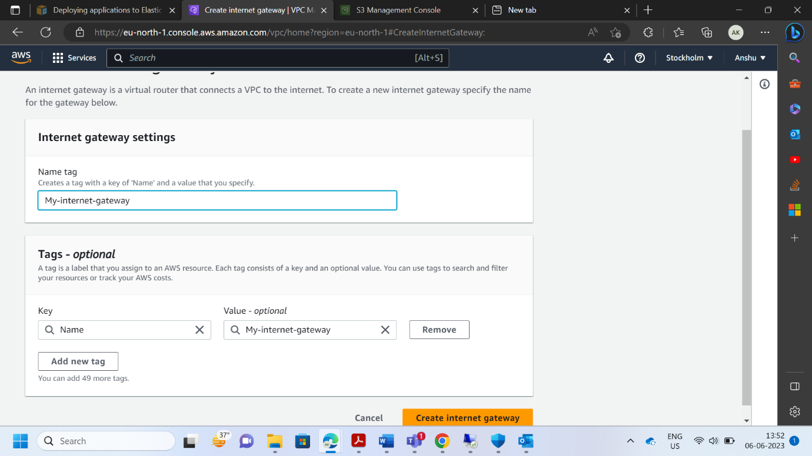
* **Attaching Internet Gateway to our VPC**

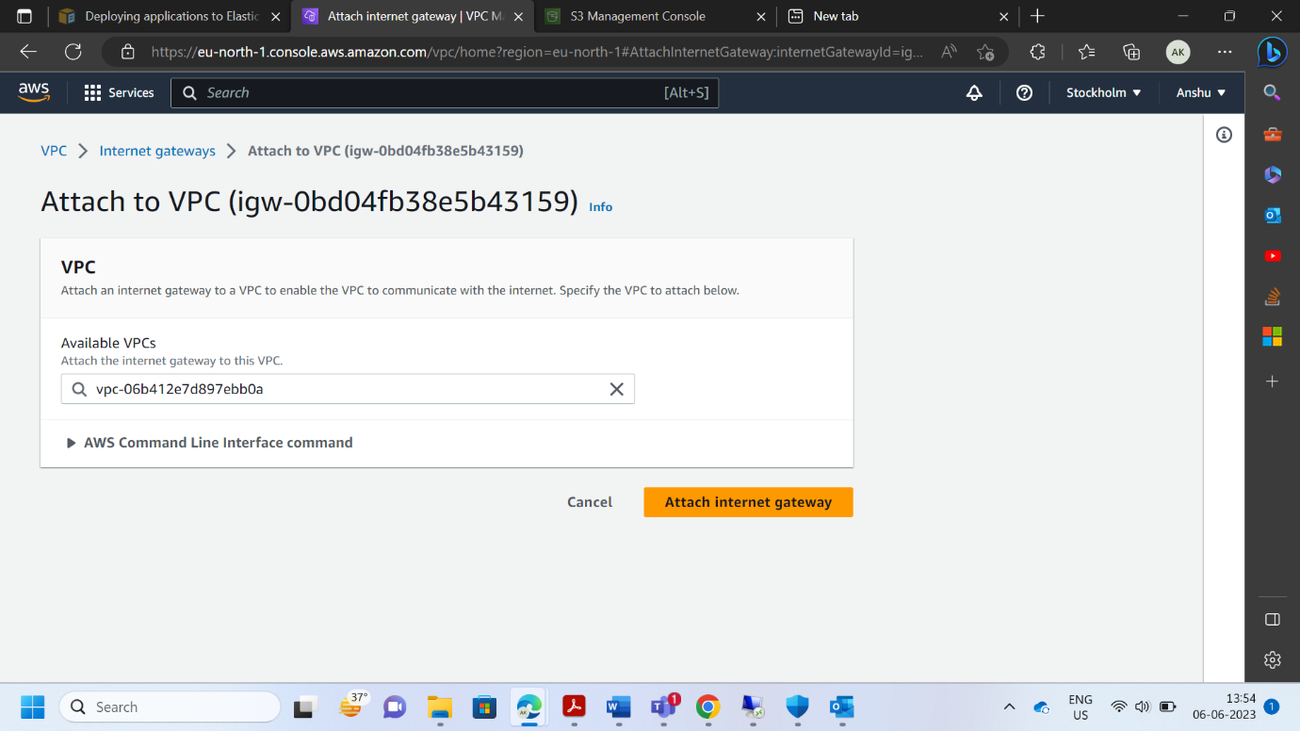

* **Creating Route Table**

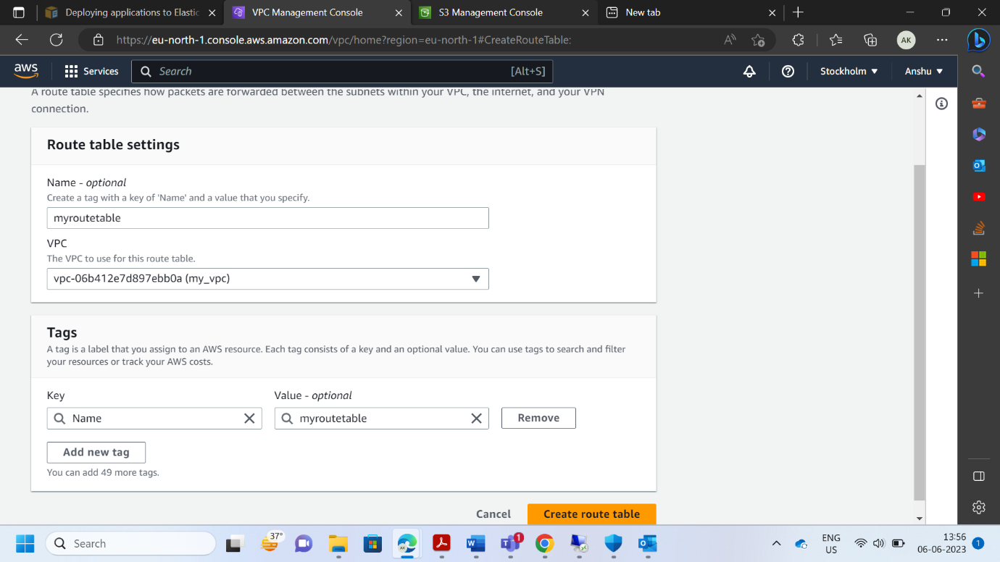

* **Editing Rout Table.**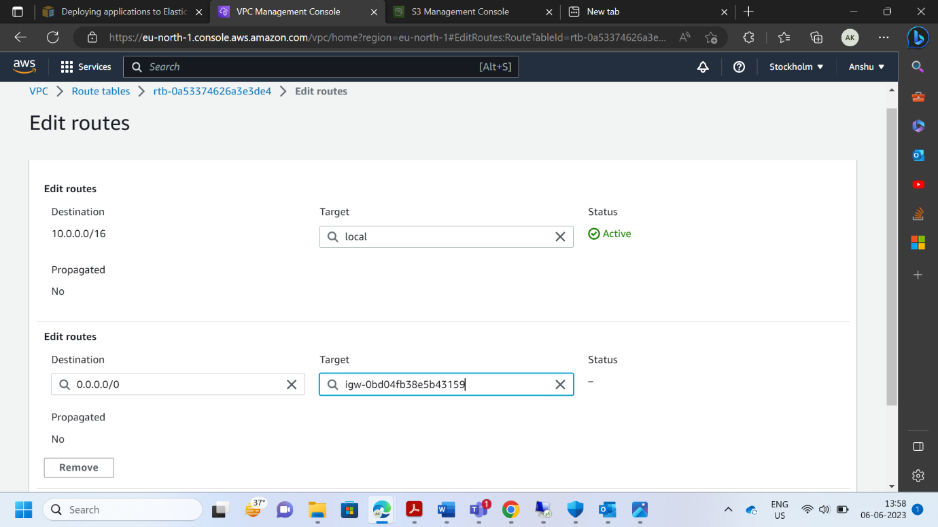

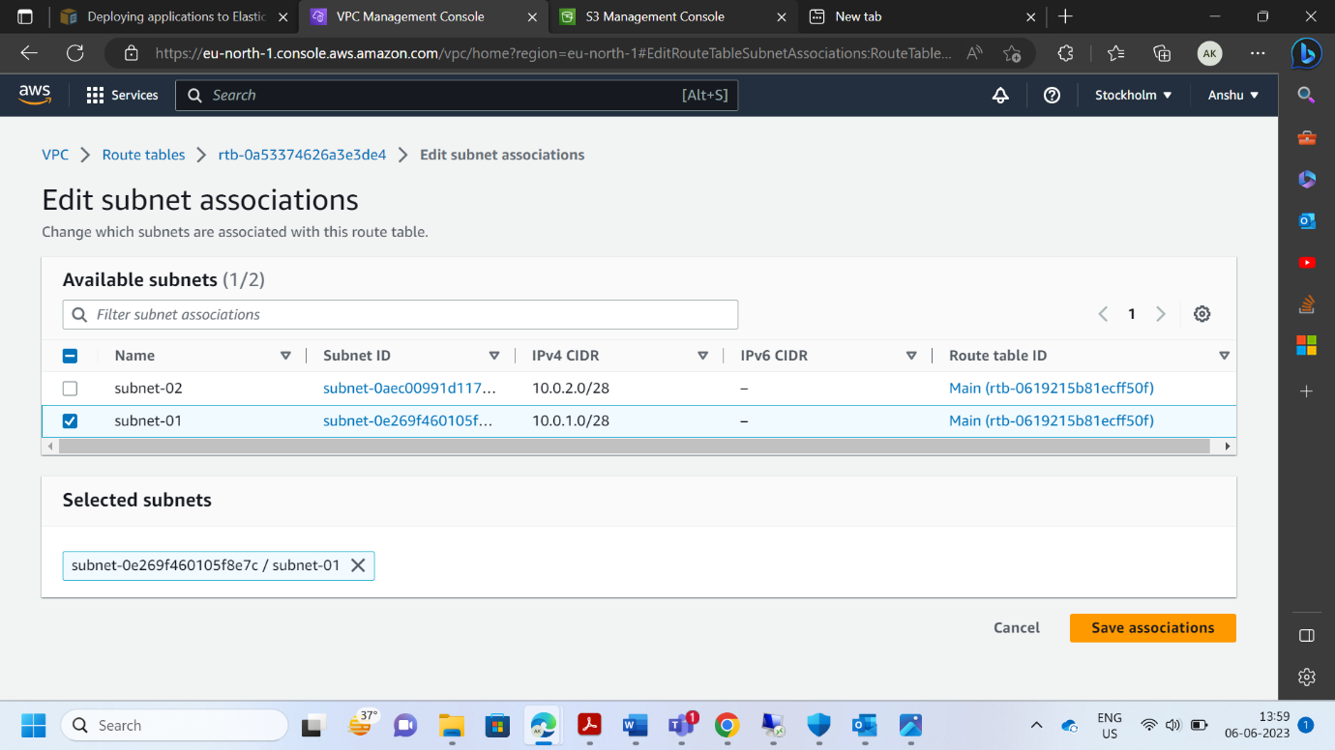

* **Creating an EC2 instance.** 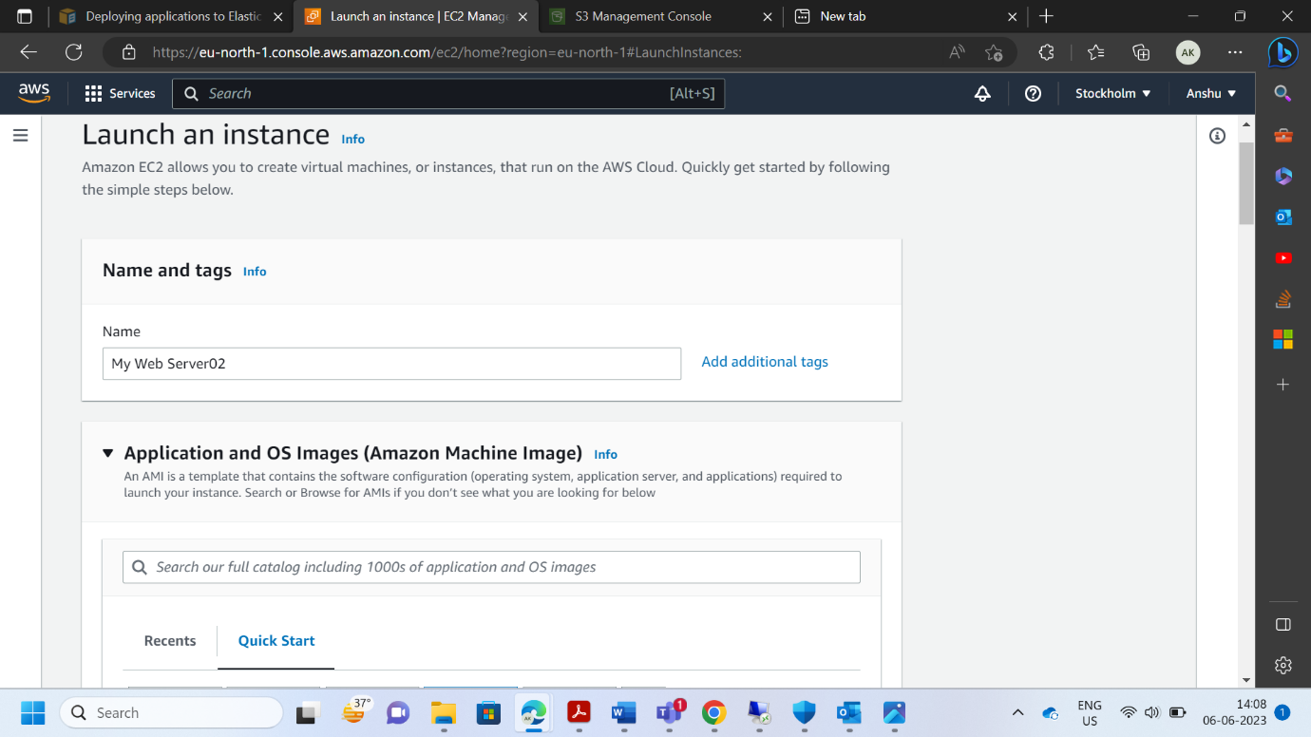

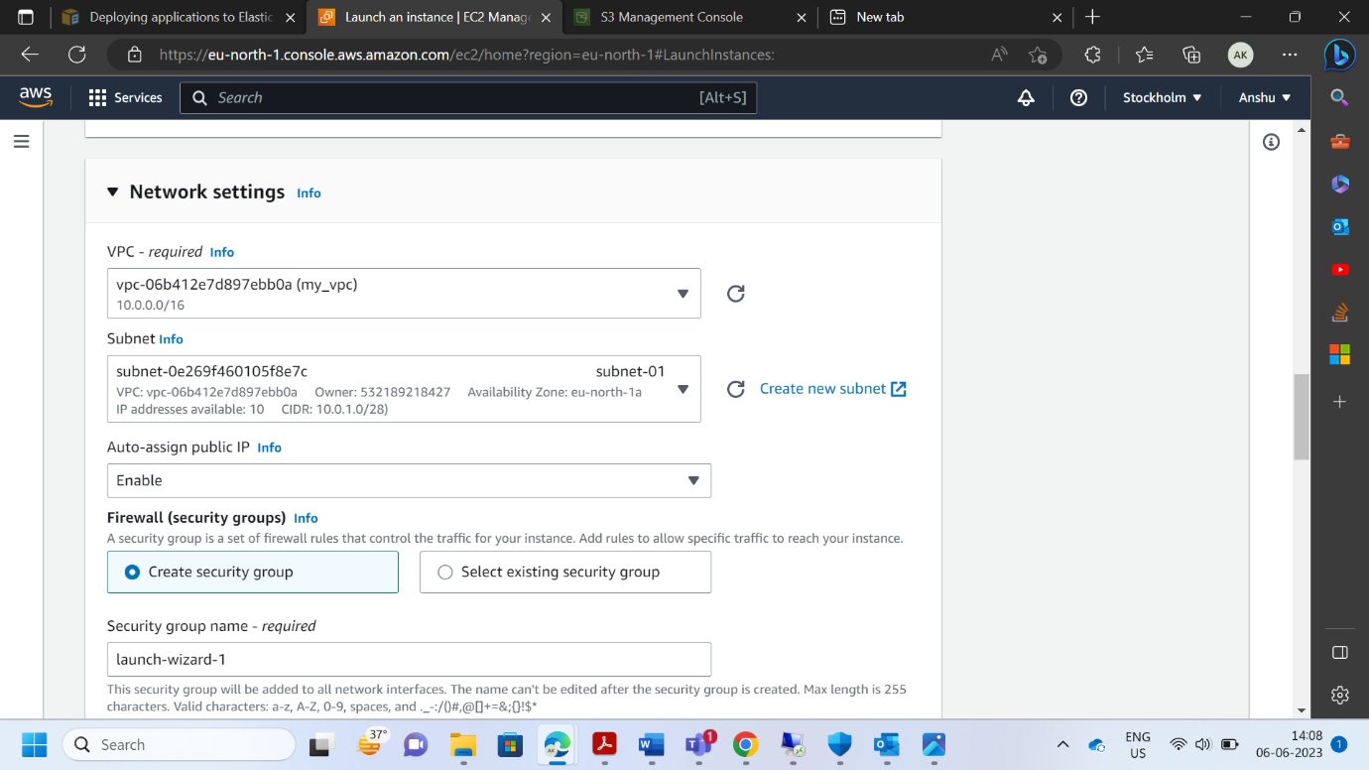

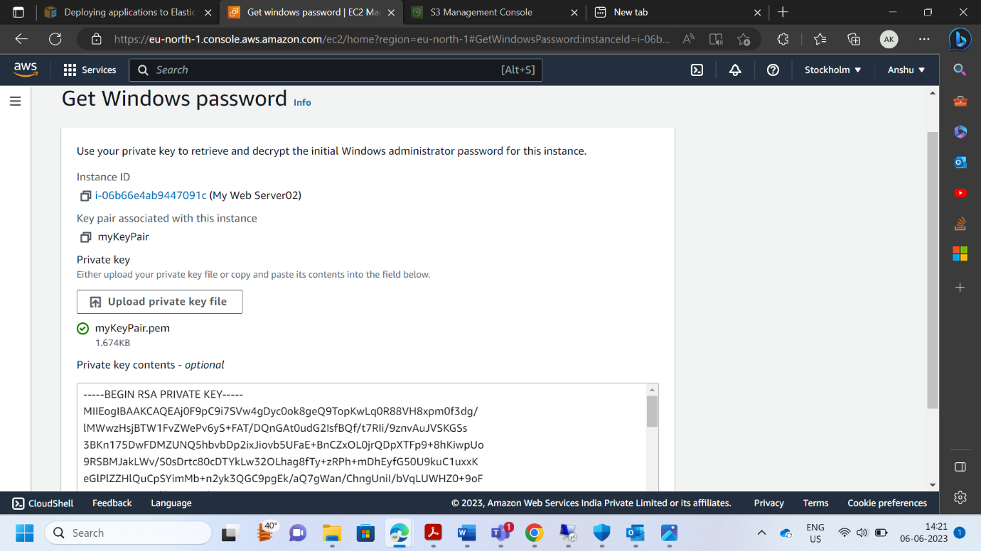

**3.**  **Deploy the same application to Elastic beanstalk Service.**

* **Creating an Elastic beanstalk Service**

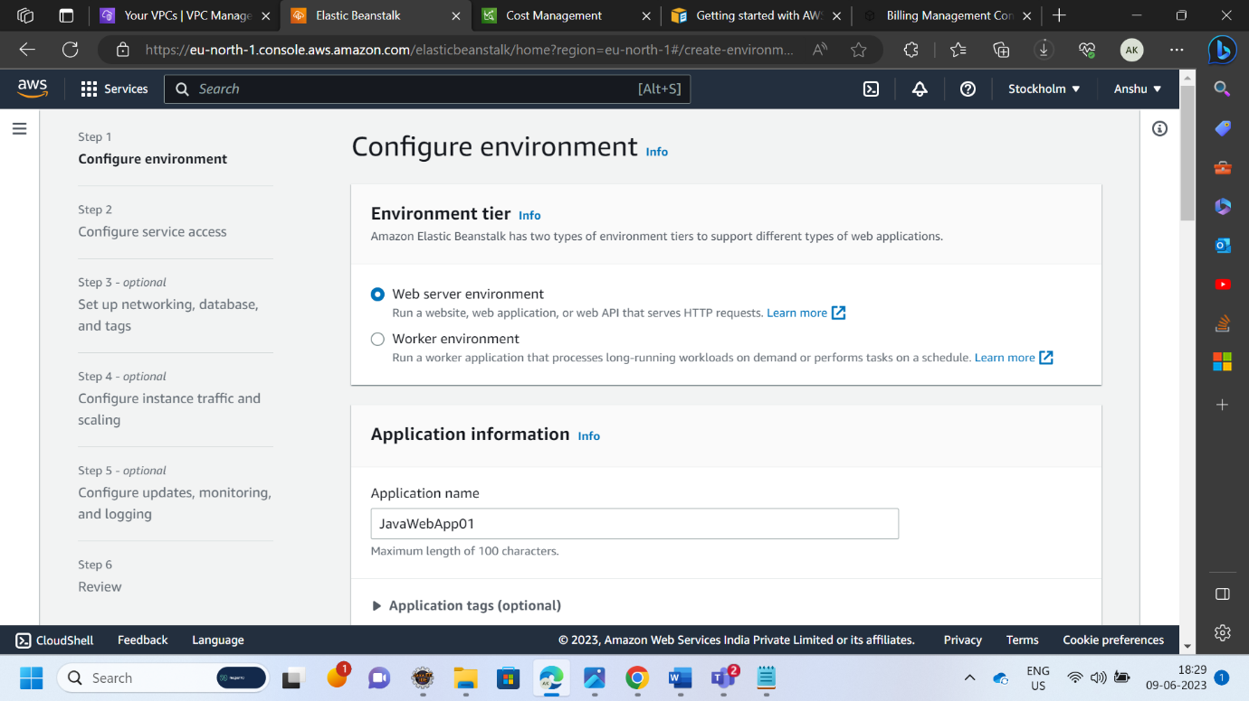

* **Deploying Application jar file in Elastic beanstalk service.**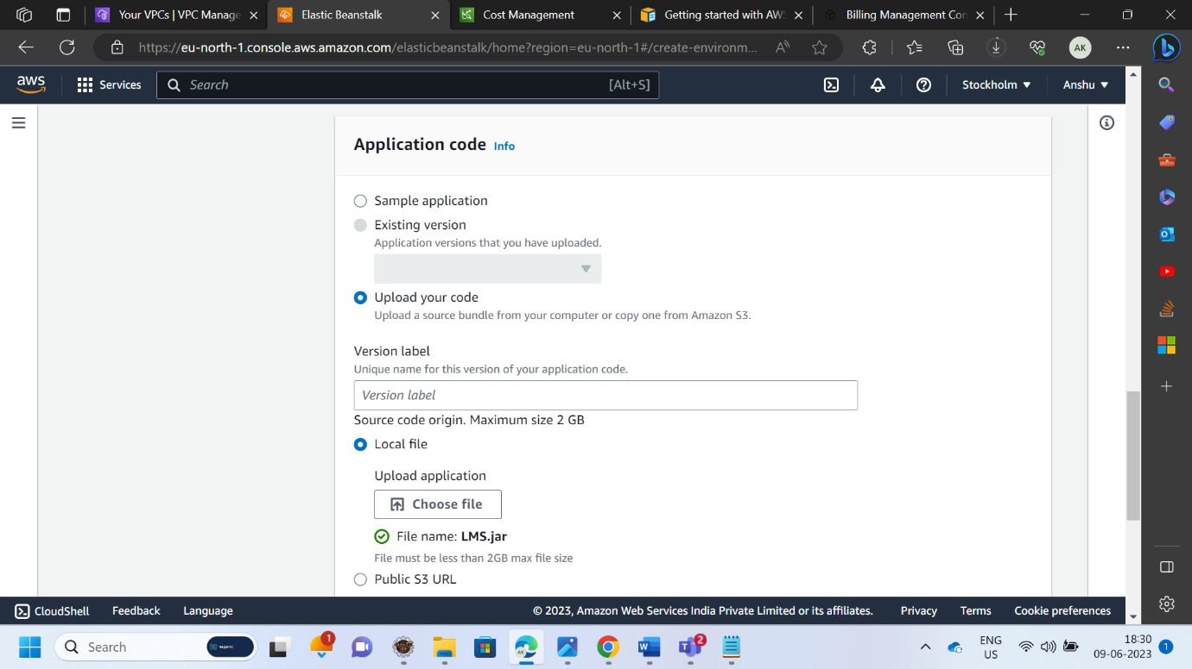
* **Creating Role for Elastic Beanstalk**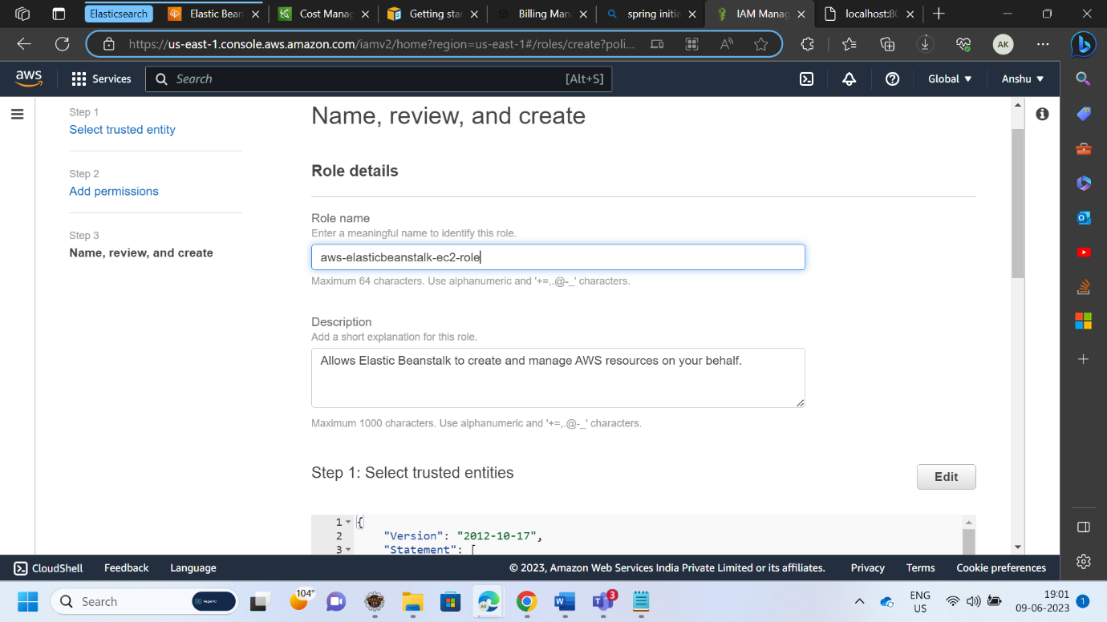

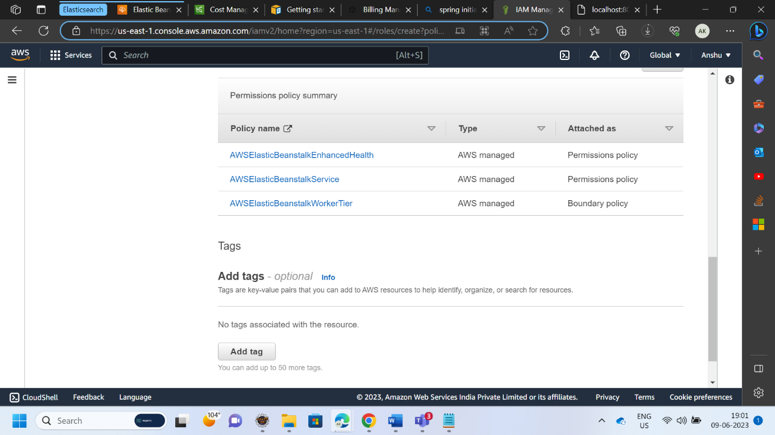

**4.** **Create a Lambda that should trigger as soon as you upload a file in the S3 bucket.**

**Function should be able to print the name of the file uploaded in the function.**

* **Creating Lambda Function**

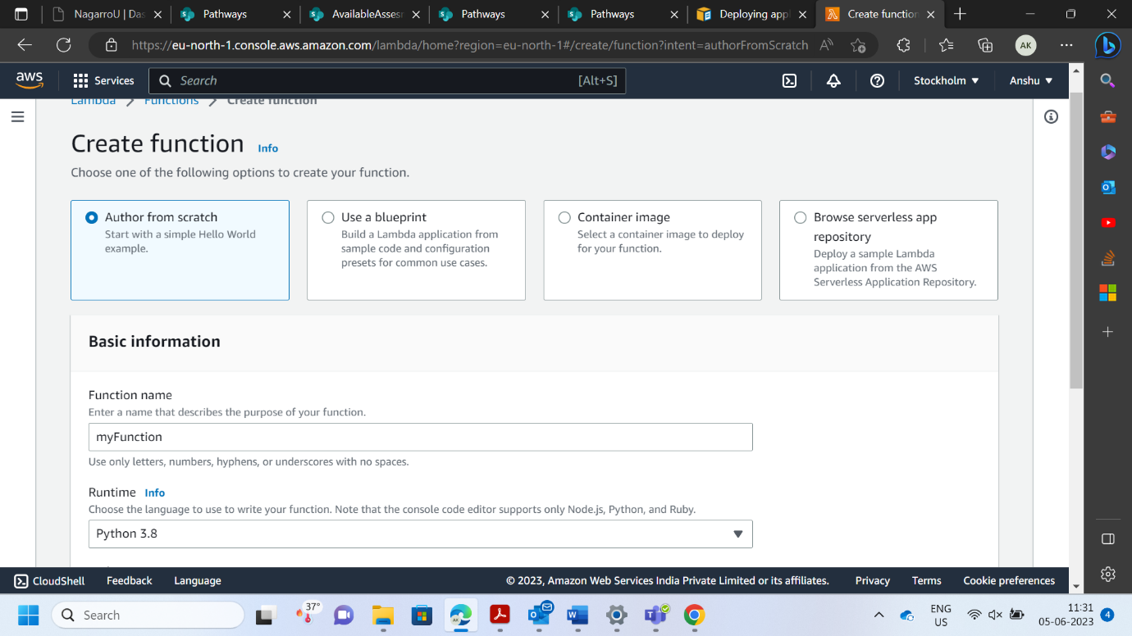

* **Editing Code to Print Name of the uploaded file**

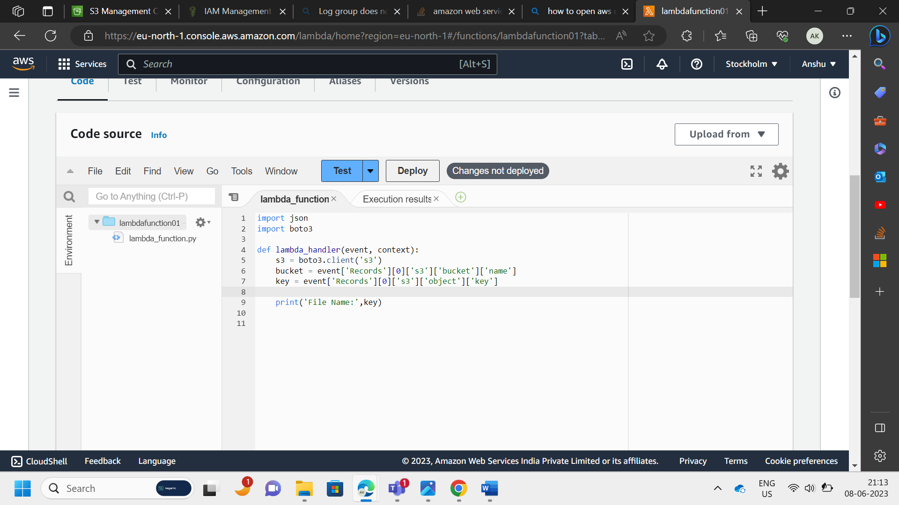

* **Creating a S3 Bucket.**

* **Adding trigger to S3 Bucket.**

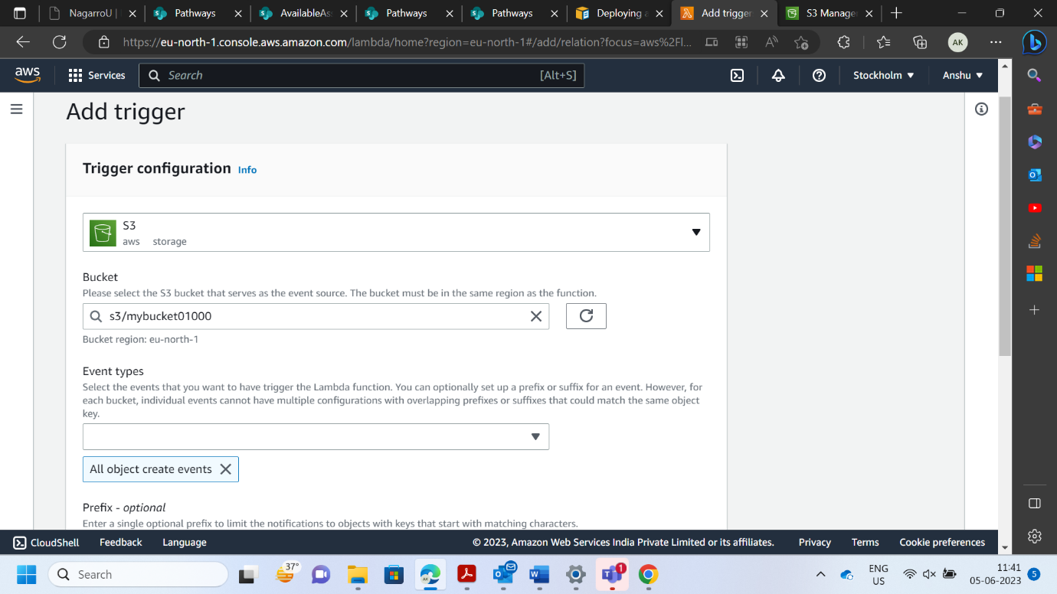

* **Uploading File to S3 Bucket.**

* **Output of the Lamba Function After Uploading file in S3 Bucket.**

